$$Session-5:Data dispersion$$

$$In order to understand data we required$$

$Central tendency$

$mean$

$median$

$mode$

$data dispersion$

$$data dispersion or data flow or data variance$$

$Range$

$Mean deviation$

$Absolute mean deviation$

$Variance$

$Standard deviation$

$$Range$$

$assume that the data ranges from 1 to 100$

$Range explain about starting point and end point$

$Range=100-1=99 parts$

$2,8,4,15,12,21 : \min{:2 \max{:21 range=max-\min{ 21-2=19}}}$

$the range is less means spread is less$

$the range value more indicates more spread$

$$Drawback:$$

$$It will not cover middile points$$

$$suppose outliers : 2,8,4,15,12,21 , 1000 =1000-2=998$$

$$2) Mean deviation$$

$$How the observations \left(data samples\right) are deviating from the mean$$

$$Consider 1,2,3,4,5 are data points$$

$$Mean=\frac{1+2+3+4+5}{5}=3$$

$$How the first observation (1) is deviating fro mean=1-3=-2$$

$$How the Second observation (2) is deviating fro mean=2-3=-1$$

$$How the Third observation (3) is deviating fro mean=3-3=0$$

$$How the Fourth observation (4) is deviating fro mean=4-3=1$$

$$How the fifth observation (5) is deviating fro mean=5-3=2$$

$$-2 units mean the observation is left side of mean$$

$$+2 units mean the observation is Right side of mean$$

$$Total deviation= -2-1+0+1+2=0$$

$$x_{1},x_{2},x_{3},x_{4},x_{5}$$

$$Mean=\overline{x}=\frac{x_{1}+x_{2}+x_{3}+x_{4}+x_{5}}{5}$$

$$How the first observation \left(1\right)is deviating fro mean=x_{1}-\overline{x}=1-3=-2$$

$$How the Second observation \left(2\right)is deviating fro mean=x_{2}-\overline{x}=2-3=-1$$

$$How the Third observation \left(3\right)is deviating fro mean=x_{3}-\overline{x}=3-3=0$$

$$How the Fourth observation \left(4\right)is deviating fro mean=x_{4}-\overline{x}=4-3=1$$

$$How the fifth observation \left(5\right)is deviating fro mean=x_{5}-\overline{x}=5-3=2$$

$$Total deviation=\left(x_{1}-\overline{x}\right)+\left(x_{2}-\overline{x}\right)+\left(x_{3}-\overline{x}\right)+\left(x_{4}-\overline{x}\right)+(x_{5}-\overline{x})$$

$$Mean deviation=\frac{1}{5}*\sum_{i=1}^{5}{\left(x_{i}-\overline{x}\right)}$$

$$Mean deviation=\frac{1}{N}*\sum_{i=1}^{N}{\left(x_{i}-\overline{x}\right)}$$

$$Draw back:$$

$$we are able to see the deviation, but the maths says the total deviation=0$$

$$this happend due to negative and postive values cancellation$$

$$3) Absolute Mean deviation$$

$$How the first observation \left(1\right)is deviating fro mean=\left|x_{1}-\overline{x}\right|=\left|1-3\right|=\left|-2\right|=2$$

$$How the Second observation \left(2\right)is deviating fro mean={|x}_{2}-\overline{x}|=\left|2-3\right|=\left|-1\right|=1$$

$$How the Third observation \left(3\right)is deviating fro mean=|x_{3}-\overline{x}|=|3-3|=0$$

$$How the Fourth observation \left(4\right)is deviating fro mean={|x}_{4}-\overline{x}|=|4-3|=1$$

$$How the fifth observation \left(5\right)is deviating fro mean={|x}_{5}-\overline{x}|=|5-3|=2$$

$$Total deviation=|\left(x_{1}-\overline{x}\right)|+|\left(x_{2}-\overline{x}\right)|+|\left(x_{3}-\overline{x}\right)|+|\left(x_{4}-\overline{x}\right)|+|(x_{5}-\overline{x})|$$

$$Aboslute Mean deviation=\frac{1}{N}*\sum_{i=1}^{N}{|\left(x_{i}-\overline{x}\right)|}$$

$$Draw back:$$

$$Draw \left|X\right| graph$$

|  |  |  |
| --- | --- | --- |
| X | Y=|X| |  |
| -3 | 3 | (-3,3) |
| -2 | 2 | (-2,2) |
| -1 | 1 | (-1,1) |
| 0 | 0 | (0,0) |
| 1 | 1 | (1,1) |
| 2 | 2 | (2,2) |
| 3 | 3 | (3,3) |

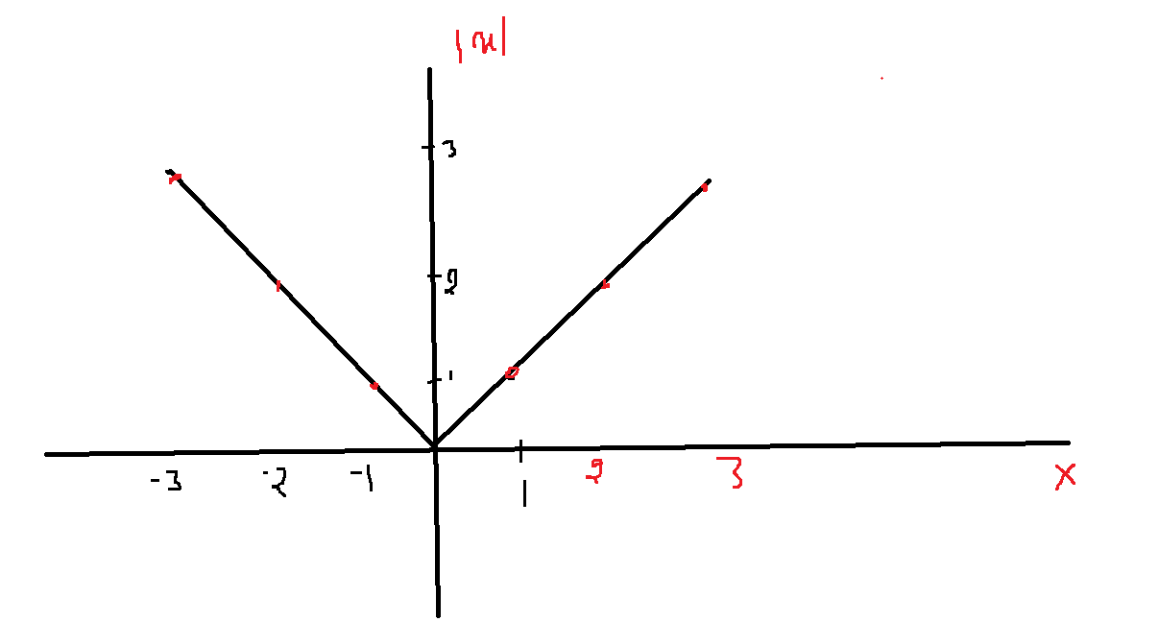

$$\left|X\right| graph does not have sharp curve at point zero, we are not able draw a free line$$

$$Differentaition and integration fails at point x=0$$

$$\frac{d\left|X\right|}{dx}=\frac{x}{\left|x\right| } when you substitute x=0 ;\frac{0}{0} which is inderminent form$$

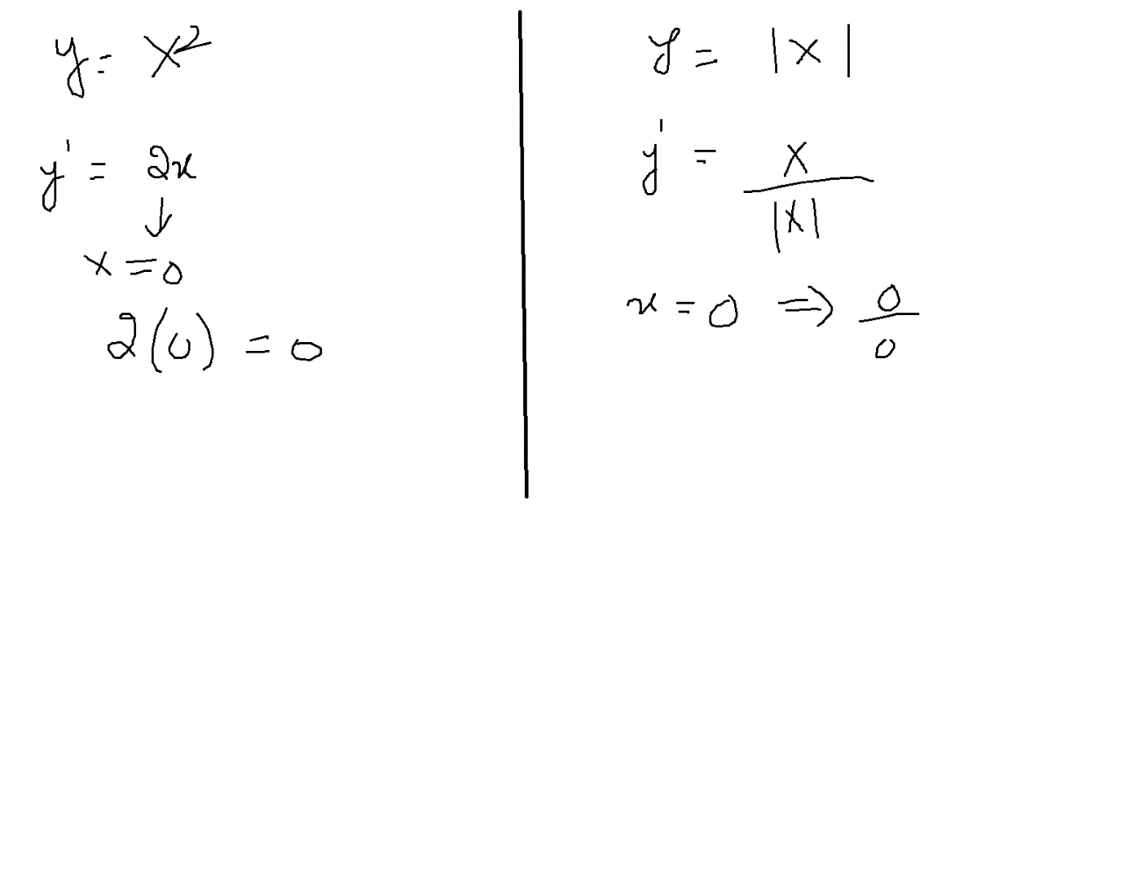

$$3) Variance$$

$$How the first observation \left(1\right)is deviating fro mean={\left(x_{1}-\overline{x}\right)}^{2}={\left(1-3\right)}^{2}=4$$

$$How the Second observation \left(2\right)is deviating fro mean={\left(x_{2}-\overline{x}\right)}^{2}={\left(2-3\right)}^{2}=1$$

$$How the Third observation \left(3\right)is deviating fro mean={\left(x_{3}-\overline{x}\right)}^{2}={\left(3-3\right)}^{2}=0$$

$$How the Fourth observation \left(4\right)is deviating fro mean={\left(x_{4}-\overline{x}\right)}^{2}={\left(4-3\right)}^{2}=1$$

$$How the fifth observation \left(5\right)is deviating fro mean={\left(x_{5}-\overline{x}\right)}^{2}={\left(5-3\right)}^{2}=4$$

$$Total deviation={\left(x_{1}-\overline{x}\right)}^{2}+{\left(x_{2}-\overline{x}\right)}^{2}+{\left(x_{3}-\overline{x}\right)}^{2}+{\left(x_{4}-\overline{x}\right)}^{2}+{\left(x_{5}-\overline{x}\right)}^{2}$$

$$Variance=\frac{1}{N}*\sum_{i=1}^{N}{{\left(x_{i}-\overline{x}\right)}^{2}}$$

$$Mean deviation=\frac{1}{N}*\sum_{i=1}^{N}{\left(x_{i}-\overline{x}\right)}$$

$$Aboslute Mean deviation=\frac{1}{N}*\sum_{i=1}^{N}{|\left(x_{i}-\overline{x}\right)|}$$

|  |  |  |
| --- | --- | --- |
| X | Y=x^2 |  |
| -3 | 9 | (-3,9) |
| -2 | 4 | (-2,4) |
| -1 | 1 | (-1,1) |
| 0 | 0 | (0,0) |
| 1 | 1 | (1,1) |
| 2 | 4 | (2,4) |
| 3 | 9 | (3,9) |

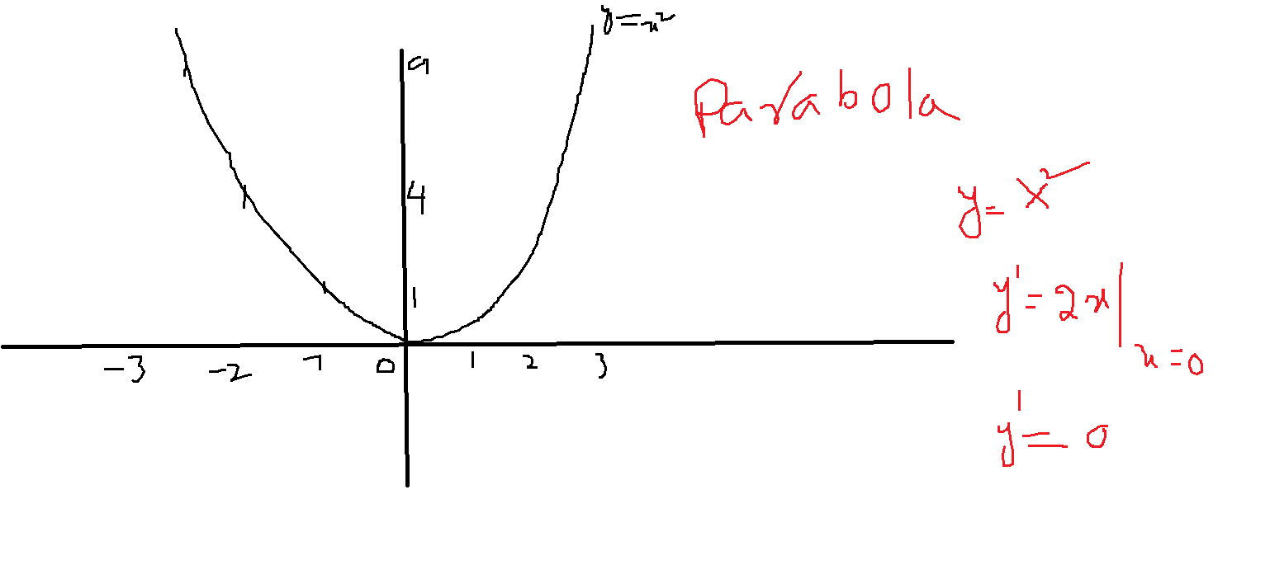

$$Draw back:$$

|  |  |  |  |
| --- | --- | --- | --- |
| KM | Mean=4 | $$x_{i}-\overline{x}$$ | $${(x}_{i}-\overline{x})^2$$ |
| 1km | 1km-4km | -3km | 9km2 |
| 2km | 2-4 | -2 | 4 |
| 3km | 3-4 | -1 | 1 |
| 4km | 4-4 | 0 | 0 |
| 5km | 5-4 | 1 | 1 |
| 6km | 6-4 | 2 | 4 |
| 7km | 7-4 | 3 | 9 |
|  |  |  | 28/7=4 variance |

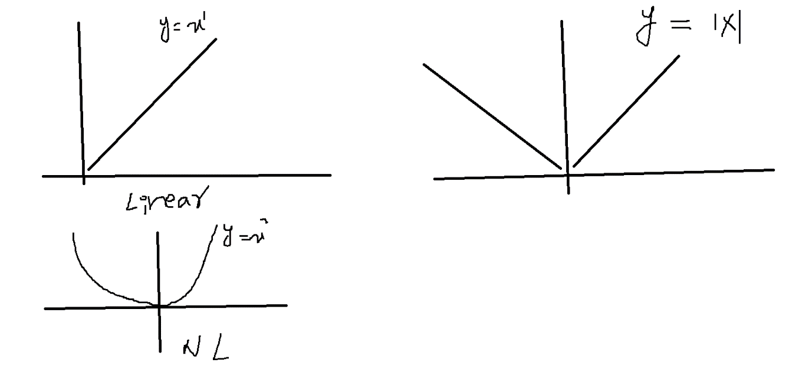

$$Standard deviation(Sd)$$

$$σ=\sqrt{var}$$

$$sd=σ=\sqrt{\frac{1}{N}*\sum_{i=1}^{N}{{\left(x_{i}-\overline{x}\right)}^{2}}}$$

$$Mean deviation=\frac{1}{N}*\sum_{i=1}^{N}{\left(x_{i}-\overline{x}\right) = Total=0}$$

$$Aboslute Mean deviation=\frac{1}{N}*\sum_{i=1}^{N}{\left|\left(x_{i}-\overline{x}\right)\right|}=Diff$$

$$Variance=\frac{1}{N}*\sum_{i=1}^{N}{{\left(x_{i}-\overline{x}\right)}^{2}}$$

$$std=σ=\sqrt{\frac{1}{N}*\sum_{i=1}^{N}{{\left(x_{i}-\overline{x}\right)}^{2}}}$$